**Leader Overview**

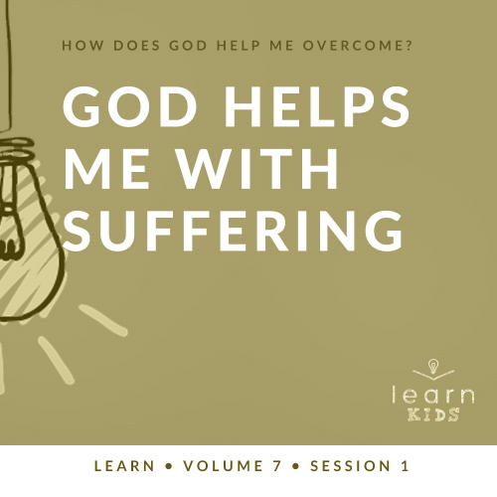

**Volume Overview**

**How does God help me overcome?**

*Life can be full of challenges. Thankfully, when we make the decision to live for God, we can have confidence that we’re no longer walking through life alone. God offers His help to us throughout every difficult circumstance. He knows that we’ll face fears, decisions, and emotions that we don’t feel equipped to handle. When we don’t know what to do, we can turn to God for the answer. He will help us overcome every challenge.*

**Session Overview**

**God Helps Me with Suffering**

*When we become a Christian, it’s easy to think that life will be easy going forward. The truth is that our relationship with God doesn’t stop bad things from happening to us. However, it does ensure that God will be with us through the difficult times. In the Old Testament, Joseph faced the terrible situation of being rejected by his own family, but God helped him through it all.*

**Bible Lesson**

Joseph Sold by His Brothers

[Genesis 37:1–11](https://ref.ly/logosref/Bible.Ge37.1-11), [18–36](https://ref.ly/logosref/Bible.Ge37.18-36)

**Faith Fact**

God helps me when bad things happen.

**Faith Verse**

[Philippians 4:13](https://ref.ly/logosref/Bible.Php4.13) (NLT)

For I can do everything through Christ, who gives me strength.

**Preparing for the Session**

**Leader Preparation Time: 20–25 Minutes**

|  |
| --- |
| ***You Will Need***  ***Large Group***   * *Bible* * *Worship songs (Song suggestions: “Nothing Is Impossible” by Planetshakers; “Won’t Let Go” by Gateway Kids Worship; “Overcome” by Elevation Worship; “Holy Ground” by Passion)* * *For groups not using a phone or tablet only, add:*   + *Projector or TV*   + *Laptop*   + ***Faith Fact Slide***   + ***Faith Verse Video*** *or* ***Slide***   + ***Bible Lesson Video***   + ***Teaching Point Slides 1–3***   + ***Large Group Game Page***   + *Scissors*   + *Bag or basket*   + *Whiteboard*   + *Dry erase marker*   ***Small Group***   * ***Small Group Group Connection Page****, one per kid* * *Pens or pencils, one per kid* * *Markers or crayons* * *Bibles for kids in your group to share* * *Whiteboard* * *Dry erase markers* * *Whiteboard eraser* * ***Small Group Activity Page****, one per kid* * *Markers or crayons* * *Decorating items (glitter, ribbon, pieces of fabric, glue, etc.)*   *To access session content and videos from a computer, visit:* [*BibleEngagementProject.com/downloads*](https://bibleengagementproject.com/downloads) |
| ***Getting Ready***  ***Large Group***   * *Download videos and slides if needed.* * *Select worship song(s) and have them ready to play.* * *Read the Bible Lesson Scripture to prepare for Teaching Time.* * *Print and cut apart the* ***Large Group Game Page****.* * *Place the marble slips in the bag or basket.*   ***Small Group***   * *Print copies of the* ***Small Group Group Connection Page****, one per kid.* * *Print copies of the* ***Small Group Activity Page****, one per kid.*   *First time leading* Learn *for Kids? Check out the* [*Facilitator Guide*](https://0b769b0ed3569ef9d18b-f88d8272f61086866d50d048b43ef630.ssl.cf2.rackcdn.com/sites/biblengagementproject/Listen_Facilitator_Guide.pdf)*.* |

**Large Group**

**30 Minutes**

*See what’s needed at the beginning of the session.*

**Introduction**

Hello, everyone! I’m so excited that you’re here. Today, we’re learning about how God helps us to overcome. There are many times in our life when bad things happen, and God wants to help us through those difficult times. Has anyone here ever had a really hard day before? *(Group response)* Yeah, me too.

• *Insert a personal story about a day that you had that was difficult. Try to keep it light and not too serious, if possible.*

**Faith Fact**

We all face hard things at times. God wants us to be ready to face these things with His help. That’s what we’re learning about today. Our Faith Fact today is **God helps me when bad things happen.**

• *Show the* ***Faith Fact Slide.***

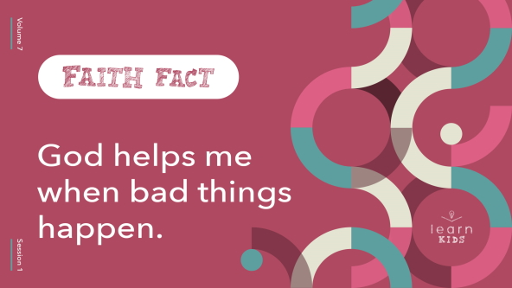

This is one of the most important things to remember today. Everyone say it as quietly as a tiny whisper. **God helps me when bad things happen**. Now, say it one more time as loud as you can. **God helps me when bad things happen**. Great job!

**Game**

**Bad Marble**

|  |
| --- |
| ***You Will Need***   * ***Large Group Game Page*** * *Scissors* * *Bag or basket* * *Whiteboard* * *Dry erase marker*   ***Getting Ready***   * *Print and cut apart the* ***Large Group Game Page****.* * *Place the marble slips in the bag or basket.* |

We’re going to play a game today called Bad Marble. You have nothing to worry about in today’s game as long as you don’t pick the bad marble. Here’s how we’ll play. First, let’s form two teams.

• *Choose a scorekeeper to come to the whiteboard.*

• *Have the scorekeeper keep a running tally of the teams’ scores.*

Each team will have one player at a time come up and choose a slip from the bag. Then they’ll show us what they drew. A picture of a blue marble is worth 100 points. A green one is 250 points. A yellow one is 500 points. There’s one marble you don’t want to pick. The red marble will lose all the points your team has earned. After you draw a slip, you’ll put it back in the bag. Got it? Let’s play!

• *Decide how many turns each team will have to draw slips before the game is over.*

Great job, everyone! That game was pretty intense. Were any of you worried that you might pick the red marble and lose all your team’s points? *(Group response)* Of all the things to face in life, this is pretty small. There are some serious things we face that can be pretty hard. Thankfully, God is here to help us in those times.

**Worship**

Isn’t it great to know that God is with us no matter what we go through? Let’s show our thanks as we worship Him. Who’s ready to worship God today by singing? *(Group response)* Let’s sing and worship Him together.

• *Lead the kids in singing one or two praise songs. See suggestions at the beginning of the session.*

**Bible Lesson**

That was an incredible time of singing and worshipping God together! He really is worth our worship! Now, it’s time to learn from God’s Word. Today, we’ll learn about someone in the Old Testament who had a lot of good things in his life. Then, he had a lot of bad things happen to him. His name was Joseph. No matter what happened to Joseph, good or bad, he honored God with his life.

Our story today starts with good things happening to Joseph. Our Bible story is about one of the first really bad things that happened to Joseph. Before we hear it, let’s pray.

**Prayer**

|  |
| --- |
| *Dear God, thank You for always being with us and helping us when bad things happen. Please help us to learn more about who You are from Your Word today. Amen.* |

**Video Intro**

Just before we look at the Bible story, let’s watch this video.

• *Play* ***Bible Lesson Video****.*

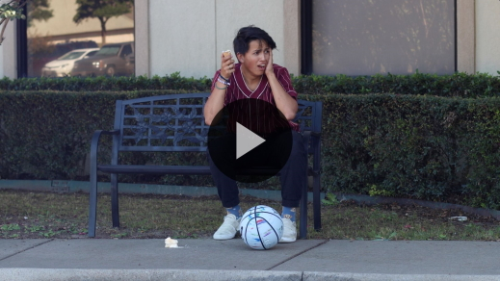

**Bible Story**

That video was such a fun lead-in to our Bible story today! Raise your hand if you’re really close with your brothers and sisters, your cousins, or maybe even a group of friends at school. *(Group response)* It’s wonderful when we have family and friends in our life who we love and trust.

What would you do if your closest friends or family turned on you? What would you do if they got you in trouble or decided they didn’t want to have anything to do with you anymore? That would be such a rough situation. Do you think it would be very difficult to forgive them? *(Group response)*

Joseph went through something like this. It was so bad! Let’s find out what happened. Grab your Bible or pull up a Bible app on your device. Turn to [Genesis 37:1–11](https://ref.ly/logosref/Bible.Ge37.1-11), [18–36](https://ref.ly/logosref/Bible.Ge37.18-36).

• *Read the Bible story aloud to the group.*

• *In order to keep Large Group time moving along, we don’t recommend having the kids read.*

• *Optional: Remind the kids to mark this place with their Bible Bookmark, so they can read it on their own at home.*

**Teaching Time**

|  |
| --- |
| ***You Will Need***  *•* ***Teaching Point Slides 1–3***  *No prep needed for this activity.* |

Wow! Could you imagine being anyone in this story? What must have been going through their minds? I think Joseph felt scared, confused, and betrayed. Joseph’s father, Jacob, was extremely sad and heartbroken. What were Joseph’s brothers thinking? *(Allow responses.)* Maybe they felt like Joseph got what he deserved, but we know at least one of the brothers didn’t really want to hurt Joseph. This was a terrible thing to happen in a family.

Thankfully, Joseph’s story doesn’t end there. Eventually he’ll see God’s favor and protection in his life. God did incredible things that proved Joseph’s dreams were true, but that didn’t happen until many years later. In today’s Bible story, Joseph was in a terrible situation. He could have become bitter and angry, or he could have chosen to trust that God would take care of him in the middle of his horrible situation. Just like Joseph, we need to trust that God helps us when bad things happen. That’s why our Faith Fact is so important. Say it with me. **God helps me when bad things happen.**

**1. God doesn’t promise us a life without trouble.**

• *Show the* ***Teaching Point 1 Slide.***

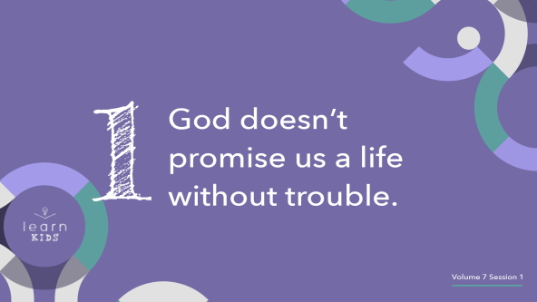

Everyone in the room, stand up. Let’s find out which bad things have happened to us. When I say something that describes you, sit down.

• Sit down if you’ve fallen and hurt yourself badly enough you needed stitches or a cast.

• Sit down if you’ve ever dropped or hit something and broke it.

• Sit down if you’ve ever had someone say or do something that hurt your feelings and you’re no longer friends with them.

• Sit down if you’ve ever had a hard day.

Friends, that’s all of us. Every one of us has had bad things happen to us. Some of us have faced really hard things like parents getting divorced or someone we love dying.

Some people think that following Jesus means that all our problems should go away or that God will never let anything bad happen again. While that sounds good, that’s not what happens when we follow God. You see God doesn’t promise us a life without trouble. In fact, Jesus told His followers that they would have hard days in this world.

That’s because this world is broken. Heaven is the only place where there are no more bad things. Until we go there, we need to know that every single one of us is going to go through bad things. Whether it’s today or many years later, we can be ready to go through it with God’s help. God doesn’t promise us a life without trouble, but He does promise to be with us when the trouble comes. That’s what our Faith Fact says. **God helps me when bad things happen.**

**2. God is with us when bad things happen**.

• *Show the* ***Teaching Point 2 Slide.***

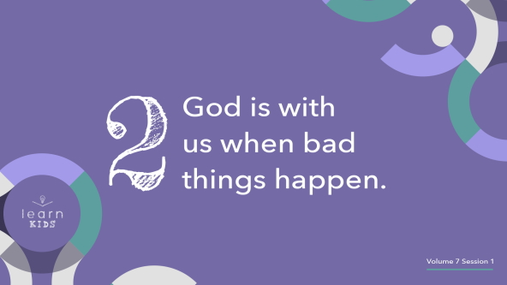

I want you to close your eyes. *(Group response)* Picture the person you go to when bad things happen. When you’re feeling down, you call or talk to them, and they’re there for you. They encourage you or spend time with you. They try to make you feel better when you’re hurt or sad. Got someone in mind? Now, open your eyes. Who is that person for you? *(Allow responses.)*

It’s wonderful that we have people in our life who can help us in hard times. It can be your mom or dad, brother or sister, a grandparent, or a really close friend. But what happens when those people aren’t there when we need them? Maybe when we call them to talk, they don’t answer. Maybe we go through something hard at school, but our mom or dad is at work. In those moments, we can remember that **God is with us when bad things happen**. We never have to feel completely alone because He is with us.

Joseph had no one in that cistern or pit with him—no friends, no brothers, no parents—but he did have God. Through many hard moments, Joseph learned that God was always with him when bad things happened. We can know this, too. We can trust that God is with us when we have people to help us and even when we don’t.

**3. We hurt when bad things happen to others.**

• *Show the* ***Teaching Point 3 Slide.***

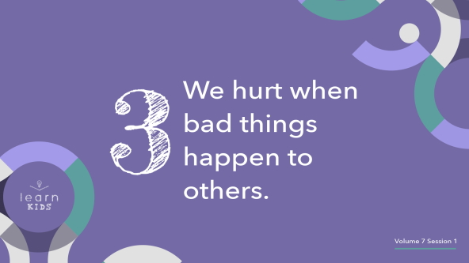

Does anyone here know the Golden Rule? What is it? *(Allow responses.)* That’s right! “Do to others whatever you would like them to do to you.” ([Matthew 7:12](https://ref.ly/logosref/Bible.Mt7.12)) This is a wonderful Bible truth to live by. When we follow this truth, it helps us treat others the way we want to be treated.

Imagine you’re having a really rough day because something terrible happened. Maybe your pet is sick or you lost something really special to you. How would you want someone to respond to your bad day? *(Allow responses.)* When I go through a hard day, it means a lot to me to know that other people care about what’s happening to me. Knowing that someone else cares makes a difference.

God knows the things that are hard for us, and He is there to help. Those hard things are called burdens. We shouldn’t only care when bad things happen to us, but we should also care when bad things happen to others.

When we show people God’s love by caring about them when bad things happen to them, it is called being burdened for someone. Being burdened for someone is saying, “Oh, I’m so sorry that happened to them. I wonder if I can do anything to let them know that they’re loved and that I’m here for them.” We can all do that for others in our life.

Our Faith Fact today is **God helps me when bad things happen**. When we truly know and believe this, we’re more prepared to handle those bad things. We can know that God doesn’t always make our problems go away, but He’s always there with us in the middle of them. Because He cares so much about our hard days, we can care about others when they go through hard times too.

**Prayer and Response**

*Consider playing a worship song softly in the background while kids pray.*

We all have burdens, or problems, that we face, and God wants to help us through them. Prayer is one way we can open up our heart to God’s help. Today, let’s ask God to help with something bad that is happening to us or someone we know.

Everyone, hold out both hands with closed fists. I want you to imagine that you’ve got that burden in your hands. We’re going to ask God to help us with it. After we pray, on the count of three, we’ll open up our hands to God to show that we’re giving it to Him and that we need His help. Think about what you need God’s help with. Then, hold out your hands.

• *Give kids time to think about what they want to give to God.*

**Prayer**

• *Optional: Have the kids repeat phrases of the prayer after you.*

|  |
| --- |
| Dear God, I know that You care about my good days and my bad days. Thank You for being with me when bad things happen. Today, please help me trust You with the hard things I face. Help me to know that You care. Help me to care for others the way that You do. Amen. |

**Faith Verse**

Our Faith Verse reminds us that during hard times, we can trust that Jesus will give us strength. Let’s say our Faith Verse and do the actions together.

• *Play* ***Faith Verse Video****.*

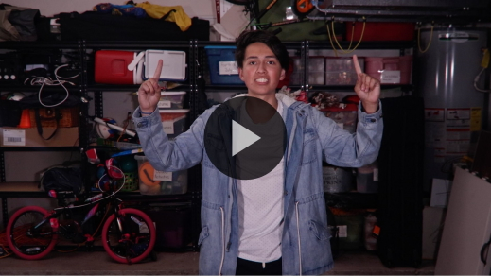

[Philippians 4:13](https://ref.ly/logosref/Bible.Php4.13) (NLT)

For I can do everything through Christ, who gives me strength.

Remember that anytime you’re having a bad day, Jesus can give you the strength you need to work through it. He is always with us, helping us through every need we have.

**Faith Fact**

Before we go to our small groups, let’s review our Faith Fact one more time.

• *Show the* ***Faith Fact Slide****.*



Say it with me. **God helps me when bad things happen**. Remember that God is with you and helping you in your hard moments. We can know His love and share it with others when they go through hard times, too.

• *Dismiss kids to Small Group time or to go home if your group time ends here.*

**Small Group**

**30 Minutes**

*This section can be done in conjunction with the large group or on its own if you do small groups with your kids. During Small Group time, the goal is to connect the kids with the Word of God and to each other. All activities are led by the small group leader.*

**Group Connection**

**How Could God Help?**

|  |
| --- |
| ***You Will Need***   * ***Small Group Group Connection Page****, one per kid* * *Pens or pencils, one per kid* * *Markers or crayons*   ***Getting Ready***   * *Print copies of the* ***Small Group Group Connection Page****, one per kid.* |

Each of us has hard days, but there are many ways that God can help us in a tough situation. He might fix it right away. More often, He’ll be with us while we face something hard. He may send someone to help us. Let’s take some time to think about what might be hard to go through.

• *Give each kid a* ***Small Group Group Connection Page*** *and a pencil or pen. Have kids write their name on the page.*

You’re only going to use the left side of this page. Write down or draw something challenging that you might experience.

• *Give kids time to complete this part. They might need help coming up with ideas.*

• *Invite them to share what they wrote or drew with the group.*

• *Collect the pages.*

Now, I’m going to give you someone else’s paper. I want you to think of how God might help that person. Write down or draw what God could do to help them through that moment. Your ideas will remind us that there are many ways God can help.

• *Here’s an example: Something hard to go through could be that I fall down and hurt myself. Some ways God can help would be these: a bandage because God has given me a body that can get better over time; a doctor or nurse because God has equipped those people to help us feel better; a friend because God has given me people to cheer me up and help me; or parents because God has given me family to help take care of me. God often uses other people in special ways to help us.*

• *Give kids time to complete this part.*

• *Invite them to share what they wrote or drew with the group.*

• *Give each page back to the appropriate kid.*

Your ideas show that there are many ways that God can help us. Sometimes He uses others to show us His love by helping people through hard times. God can use us, too.

**Learn about It**

|  |
| --- |
| ***You Will Need***   * *Bibles for kids in your group to share*   *No prep needed for this activity.* |

**Scripture Search:** [**2 Corinthians 1:3–7**](https://ref.ly/logosref/Bible.2Co1.3-7)**;** [**1 Corinthians 12:25–27**](https://ref.ly/logosref/Bible.1Co12.25-27)**;** [**Philippians 1:28–30**](https://ref.ly/logosref/Bible.Php1.28-30)**;** [**Hebrews 2:16–18**](https://ref.ly/logosref/Bible.Heb2.16-18)

Let’s dig deeper into God’s Word and see what else He has to say to us. As we find and read each of these verses, let’s consider: What does this Scripture mean for our life today?

• *Give each kid a Bible and search for one or more of the Scriptures as a group together (as time allows). When everyone has found the Scripture, have one of the kids read it. Then, answer the questions about it.*

• *Pair kids who need additional help with older kids or start simple and look up the session’s Bible story Scripture:* [*Genesis 37:1–11*](https://ref.ly/logosref/Bible.Ge37.1-11)*,* [*18–36*](https://ref.ly/logosref/Bible.Ge37.18-36)*. Kids will get better at finding Scriptures the more they practice.*

• *Optional: Make this a competition to see who can find the Scripture first.*

**Bible Reading Tip**

God’s Word is so good. Did you know that some Bibles come with a list of verses by topic? This list will be either in the front or back of the Bible. You can use it to find verses centered around one topic like worry, anger, love, prayer, forgiveness, heaven, and many other things. If you use a Bible app, some of them have reading plans about different topics that show you verses about one subject.

**Challenge**

Here’s a challenge for you. Listen carefully to others this week. If you hear someone talk about how they’re sad, angry, lonely, or facing a hard time, use a topic list of Bible verses like we just talked about. Find a verse to share with them about whatever they’re going through. The Bible verse you share could be exactly what your friend or family member needs to hear.

**Faith Fact**

The Bible is a powerful tool that God uses to help us. That reminds me of our Faith Fact. **God helps me when bad things happen**. Let’s think about the emotions we feel when bad things happen. Then, we’ll say the Faith Fact that way. Show me your saddest face. *(Group response)* Let’s say the Faith Fact in a sad voice. **God helps me when bad things happen**. Show me your angry face. *(Group response)* **God helps me when bad things happen**. What does your face look like when God helps you? *(Group response)* **God helps me when bad things happen.**

**Group Discussion**

*Feel free to use all or just a few questions as a jumping-off place for good discussion. Questions marked with * are designed for more conversation. Adjust the questions based on the age or maturity of your group. Typically, older kids will be able to dive a little deeper than younger ones.*

**Questions**

• *If small group activities are not immediately following large group time, you may want to read the Bible story passage before this discussion.*

What were Joseph’s dreams about?

Why didn’t his brothers like the dreams?

What did Joseph’s brothers decide to do to him?

What did Joseph’s brothers tell their father had happened?

* What stuck out to you most about this story?

How do you think God helped Joseph in the middle of his bad situation?

Does following God make all our problems go away? Why or why not?

* What are ways that God is with us during hard times?

* What should we feel when others are going through a bad situation? What are ways we can help them?

* How would your life be different if you trusted that God would help you every time bad things happened?

**Prayer Requests**

*Finish group discussion by sharing prayer requests and praise reports. Keep track of your small group’s prayer requests and review them each time you meet.*

**Prayer**

*Have kids pray for one another’s prayer requests.*

**Faith Verse Review**

|  |
| --- |
| ***You Will Need***   * *Whiteboard* * *Dry erase markers* * *Whiteboard eraser*   ***Getting Ready***   * *Write the Faith Verse on the whiteboard.* |

Our Faith Verse is [Philippians 4:13](https://ref.ly/logosref/Bible.Php4.13). This verse reminds us that God helps us have strength to overcome the difficult situations in our life. Let’s review it now.

• *Show* ***Faith Verse Video****.*



[Philippians 4:13](https://ref.ly/logosref/Bible.Php4.13) (NLT)

For I can do everything through Christ, who gives me strength.

When bad things happen to us or around us, this verse tells us that Jesus gives us strength. Let’s review our Faith Verse as a group a couple of more times. Try to memorize it as best as you can because you’ll need to know it for the Faith Verse game.

• *Say the verse as a group a couple of times*.

**Faith Verse Fun**

**Word Wipeout**

Let’s take some time to learn this new Bible verse. Let’s play Word Wipeout.

Let’s read the Faith Verse together one time to keep it fresh in our mind. Pay attention because we’re about to challenge our memory.

• *Read the verse together.*

Now, we’ll take turns erasing words and replacing them with lines before saying the verse again. Let’s see if we can keep saying the verse as the words disappear.

• *Each time the group recites the verse, have a volunteer erase one word from the verse, replacing the word with a line. Recite the verse again.*

• *Repeat until the whole verse is erased.*

• *If you’re short on time, consider erasing multiple words at a time.*

Great job, everyone! We’re learning our Faith Verse. I hope that when you face something difficult this week, you’ll remember this verse.

**Activity Page**

**Design a Coat**

|  |
| --- |
| ***You Will Need***   * ***Small Group Activity Page****, one per kid* * *Markers or crayons* * *Decorating items (glitter, ribbon, pieces of fabric, glue, etc.)*   ***Getting Ready***   * *Print copies of the* ***Small Group Activity Page****, one per kid.* |

Joseph’s dad, Jacob, gave Joseph a beautiful coat. That was one of the things that made Joseph’s brothers jealous. Have you ever wanted a gift that someone else received? *(Group response)*

We don’t have a picture of what Joseph’s coat looked like, so I want you to use your imagination. Make Joseph’s coat look amazing.

• *Give the kids the* ***Small Group Activity Page*** *and decorating items. Let them design Joseph’s coat.*

**Dismissal**

Always remember that God will help you when bad things happen. No matter how big or small, God cares about your problems and is with you through all of them just like He was with Joseph. We know that bad things will come, but God is always with us. God also wants us to have that same heart for others around us. We can be there for them when they face hard times. Let’s close in prayer.

**Prayer**

|  |
| --- |
| *Dear God, thank You for always being with us and for helping us when bad things happen. We love You and trust You. Please help us to be ready for the hard days. We know You’re with us. Help us show Your love to others when they have difficult days, too. Amen.* |

**Faith Fact Recap**

• *Show the* ***Faith Fact Slide****.*



I’m so glad that we got to learn this powerful truth together today. Let’s say it one more time. **God helps me when bad things happen**. I’m really glad you came today. I can’t wait to see you next time**.**

• *Send home the* ***Small Group Activity Page*** *and the* ***Small Group Group Connection Page.***

• *Remind parents that there are* ***Family Devotions*** *available on the app to do with their kid.*

• *Tell everyone the date and time for the next session*.